How to introduce a new adult cat to your cat
It is always going to be potentially difficult to introduce a new adult cat to your resident cat. It is important to recognize that even when the introduction process is conducted as carefully as possible, this is not a guarantee that the cats will happily accept one another. Some cats simply do not want to live with other cats and it is important that you are able to recognize and act on this in order to ensure the cats in your care have the best well-being possible.
Your cats may live with you for many years. Getting the introduction right and taking extra time if necessary to carry it out could make a huge difference to their attitude to each other. Not only do owners feel much better if their cats get on rather than disliking each other, but also the cats’ stress is reduced considerably.
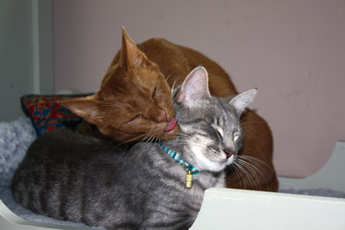
Setting up the home for your new cat
If you have made the decision to get a new cat, the first step when you bring it home is to confine the new cat to a single room. Ideally, pick a room that your resident cat does not use much and that you do not need constant access too, perhaps a spare bedroom or study.
Ensure the new cat’s room contains:
- Food
- Water
- Comfortable resting areas with bedding
- Hiding places
- Litter Box
- Toys
- Scratching post
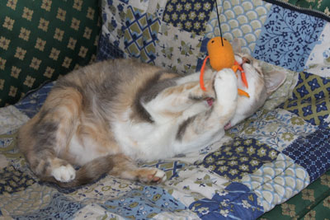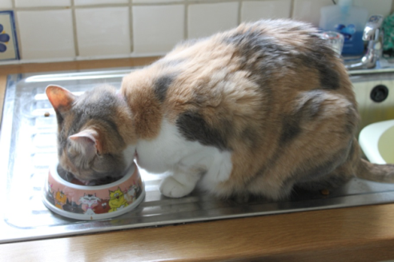
These items should be those that came with the cat, or brand-new. It is not a good idea to use some of your resident cat’s belongings as these will smell of your resident cat, which may make your new cat uneasy at a time when you are trying to help it to feel relaxed in its new surroundings. Likewise, reducing the number of belongings your current cat has (e.g., the loss of a litter box) has the potential to cause it distress.
In addition, the use of synthetic feline facial pheromone Feliway in both the new cat’s room and in the area where the resident cat spends the most time will help to create feelings of familiarity and security within the physical environment. For the new cat, this may help to speed up adaption to the new environment and, for the resident cat; it may help prevent any feelings that its territory is being threatened.
Give the new cat plenty of time to become accustomed to the routines of the new home and the people that live within it, and to allow your new cat’s scent to become part of its room. This will occur:
- Actively by your cat rubbing its scent gland areas on its face against furniture and the corners of the walls and by scratching its scratching post
- Passively by your cat sleeping and resting on bedding and playing with toys
Depending on the cat, this acclimatization period could vary from several days to a week or two. Signs that your new cat is comfortable with its new environment include:
- Friendly behaviors when you enter the room such as approach, rubbing around your legs, chirruping, purring and meowing
- Resting on its side with belly exposed and rolling over
- Playing with its toys
- Facial rubbing on furniture, corners of walls and other items in its room
- Normal eating, drinking, grooming and toileting behaviors
If your new cat is showing any signs of being frustrated (see below) at being kept in a single room, you may wish to provide it with more space such as a corridor or additional room that your resident cat does not access. If this is not possible, it may be advisable to start the introduction process earlier.
Signs of frustration at being confined include:
- Scratching or pawing at the door and surrounding area, or at the windows
- Meowing for several minutes at a time
- Pacing by the door
- Rearing up at the door
- Swiping at you when you try to leave the room
Scent swapping
Once the cat is fully comfortable in its own part of the home, it is time to begin the process of introducing the cats to one another. Start by gradually introducing the scent of the other cat to each cat (without actually physically meeting). This is essential as cats use the scent of individual cats to recognize whether they are in the same social group or not. Our aim is for the cats to recognize one another as part of the same social group by creating a communal scent.
The idea behind scent swapping is that both cats become fully comfortable in the presence of the smell of the other cat before physically meeting. By ensuring this, there is a greater chance they will accept the physical presence of one another as they are more likely to consider each other as part of the same group.
Step 1: Exchange bedding
Begin scent swapping by taking one piece of each cat’s bedding (e.g., a single blanket) and placing it in one of the other cat’s beds. There should be ample bedding for both cats so that this change in bedding does not leave either cat with limited sleeping/resting sites. It is hoped that each cat will rest upon the bedding of the other cat, thereby mixing their two scents to create a communal scent. Quietly observe both cats’ reactions to the bedding. A cat that shows negative behaviors towards the bedding such as actively avoiding it or even hissing at it may be less likely to accept a new cat into its home and therefore will need to progress through the steps at a much slower pace.
Once the cats are showing relaxed behavior in the presence of the bedding, the bedding can then be replaced back into the original cat’s room to allow further mingling of scent. This process can be repeated for more than one piece of bedding.
Extra tip: It is always a good idea, if possible, to try and obtain some bedding from your new cat before you bring it home so that you can gauge your resident cat’s reaction to the new cat’s scent as early as possible. If the resident cat accepts the smell of the new cat before it is physically in the home, then it may have a better chance of coping with hearing, seeing and smelling (at a greater concentration) the new cat when it does come home.
If the cats enjoy being stroked, then a light cotton glove can be worn while stroking the cats (one glove for each cat) or a cloth wiped over each cats’ facial glands (under the chin, cheeks and areas in front of the ears) and then wiped onto the furniture in the part of the home the other cat lives in. This will allow further scent exchange and the opportunity for the cats to facial rub on top of the marks and create a communal scent.
Step 2: Allow exploration of each cat’s area
If the cats show no adverse signs to the smell of one another on the bedding (and on the rubbed areas) then, as an additional step, the resident cat could be briefly confined (for example, during the night the resident cat could be confined to the owner's bedroom) to allow the new cat to inspect the resident cat’s area of the home. Confinement should only occur however, if unlikely to cause any distress such as frustration. Conversely, the new cat could be temporarily removed from its room (and confined elsewhere) to allow the resident cat to explore the room. It is recommended that the latter occurs only when the new cat is entirely relaxed and therefore this is unlikely to be advisable until several days after the introduction of the new cat.
Step 3: Allow visual contact
The cats should only be allowed to see one another once they are fully relaxed in the home in general and when encountering the scent of the other cat. Being able to see each other should happen through a physical barrier. This can be achieved in a number of ways including:
- A closed glass door
- A physical barrier placed in a door way such as a netted or mesh temporary door
- A small crack in the door, narrower than the width of a cat’s body
- Having one cat inside a crate. This method should only involve one cat per crate and is therefore best when a new cat is only being introduced to one resident cat. However, the crate itself must never be a source of distress for any of the cats. A crate should therefore have been previously placed in each cat’s core area with enticing resources such as food and soft bedding in order to make the crate both familiar and perceived positively. Experiencing being shut in the crate as a positive experience (e.g., associating it with food treats) should occur in each cat’s part of the home so the cat is fully comfortably with this confinement before experiencing it in the presence of another cat. Furthermore, the crate should always contain a hiding place for the cat to remove itself from visual view. This could be provided by placing a cardboard box or igloo bed in the crate or by covering a portion of the crate in a towel or blanket.
Being in the visual presence of one another should be associated with pleasant feelings. Thus cats can be played with or fed food treats, both activities occurring separately. It should never be a staring contest. Instead, the cats should be happy going about their own activities while being able to glance at one another. If they wish to sniff each other through the barrier, allow this but any sign of negative behavior to one another (e.g., growling, hissing, flattening or rotating of ears with tense body posture) should be instantly distracted, for example by luring the instigator of the negative behavior out of sight of the other cat using a toy such as a fishing rod toy. Cats should never be punished for showing negative behaviors to one another as this is only likely to frighten the cats more.
If there is more than one resident cat, visual contact should initially occur between just two cats (one resident each time and the new cat) and then progress to more cats (more residents and the new cat).
Keep the sessions short and finish while they are still doing well, that is, interested in the food/toy provided and showing no negative behaviors or signs of distress. If either cat shows any signs of distress or negativity towards each other, separate the cats physically and visually immediately.
Step 4. Physical access but supervised contact
This next stage should only occur when cats are fully comfortable with seeing one another through a barrier. Removing or opening the barrier should happen quietly, ideally at a time when the cats are both engaged in a pleasurable activity such as play or feeding. Never force the cats together and try to observe passively. The main aim is that the cats are comfortable with the presence of one another; they do not need to be physically interacting. If the cats show any signs of negativity towards one another or any signs of distress, replace the barrier to separate the cats and go back a stage. If cats appear to be relaxed in the company of one another, then physical supervised access should be as frequent as possible.
Step 5. Free access without supervision for short periods
Free unsupervised access for short periods of time (a few minutes) can occur as long as there is no negative behavior between the cats during the ‘physical access but supervised contact’ stage. Once commenced, free unsupervised access should be as frequent as possible. At other times the new cat is still kept separated. If friendly behaviors are seen between the new cat and the resident, they can be kept together for increasingly longer periods although always make sure they have access back to their own parts of the house. At this stage, it is particularly important that each cat has its own resources in separate locations from each other (i.e., not all in one room) and from the resources of the other cat(s) in the household as this will help prevent the cats from feeling in competition with one another.
With time, if things are going well, the separate room can be kept permanently open and the new cat and resident cat(s) are free to come and go as they please. In some cases, however, where some conflict begins to show, a separate room or other restricted area (e.g., accessed through microchip operated cat flaps) can be made available to a single individual or individuals that do get along well, allowing cats to access the whole environment but also to retreat to areas in the absence of the cats they show conflict with. Additional opportunities for utilizing vertical space such as shelves, walkways and perches can help cats to maintain their own space. The key point is to continue to monitor, as relationships between cats can change over time and between different contexts, and adapt according to the cats.
If you are struggling to successfully complete this introduction process or the cats experience a breakdown in an initially good introduction, it is a good idea to seek professional help. Contact your vet who will be able to provide you with advice or refer you to a qualified behaviorist.

